Tab 8
ITA0601
MACHINE LEARNING

EXP 18

Implement Perceptron based IRIS classification

Procedure
1. Import the Iris dataset and Perceptron classifier.
2. Load the Iris dataset.
3. Train the Perceptron model using the training data.
4. Predict the flower class.
5. Display the predicted result.

Dataset 1: Fruit Classification
Target Variable (Fruit): Apple / Orange

Training Data
Weight (g) | Diameter (cm) | Sweetness (%) | Fruit
150 | 7.5 | 90 | Apple
160 | 7.8 | 88 | Apple
145 | 7.3 | 91 | Apple
120 | 5.5 | 70 | Orange
125 | 5.8 | 72 | Orange
130 | 6.0 | 74 | Orange
155 | 7.6 | 89 | Apple
118 | 5.4 | 69 | Orange
148 | 7.4 | 92 | Apple
122 | 5.7 | 71 | Orange

New Sample for Classification
Weight (g) | Diameter (cm) | Sweetness (%)
152 | 7.5 | 90

PROGRAM

import numpy as np

X=np.array([[150,7.5,90],[160,7.8,88],[145,7.3,91],[120,5.5,70],
[125,5.8,72],[130,6,74],[155,7.6,89],[118,5.4,69],[148,7.4,92],[122,5.7,71]],float)

y=np.array([1,1,1,0,0,0,1,0,1,0])

# Scale features
X=(X-X.mean(0))/X.std(0)

w=np.zeros(3)
b=0

for _ in range(20):
for x,t in zip(X,y):
p=1 if np.dot(x,w)+b>=0 else 0
w+= (t-p)*x
b+=t-p

sample=np.array([152,7.5,90])
sample=(sample-X.mean(0))/X.std(0)

p=1 if np.dot(sample,w)+b>=0 else 0
print("Predicted Class:", "Apple" if p else "Orange")

OUTPUT

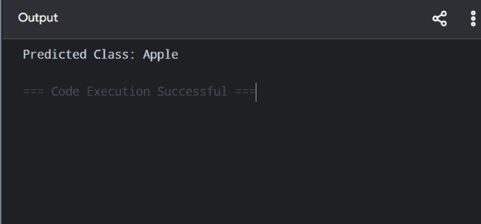

Dataset 2: Student Placement Classification
Target Variable (Placement): Placed / Not Placed

Training Data
CGPA | Aptitude Score | Communication Score | Placement
9.3 | 92 | 90 | Placed
8.9 | 87 | 85 | Placed
8.6 | 84 | 82 | Placed
7.3 | 74 | 72 | Not Placed
6.9 | 69 | 67 | Not Placed
9.1 | 91 | 89 | Placed
7.4 | 75 | 73 | Not Placed
8.7 | 85 | 83 | Placed
6.6 | 64 | 60 | Not Placed
8.8 | 88 | 86 | Placed

New Sample for Classification
CGPA | Aptitude Score | Communication Score
8.8 | 86 | 84

PROGRAM

import numpy as np

X=np.array([[9.3,92,90],[8.9,87,85],[8.6,84,82],[7.3,74,72],
[6.9,69,67],[9.1,91,89],[7.4,75,73],[8.7,85,83],[6.6,64,60],[8.8,88,86]],float)

y=np.array([1,1,1,0,0,1,0,1,0,1])

m=X.mean(0); s=X.std(0)
X=(X-m)/s

w=np.zeros(3); b=0

for _ in range(20):
for x,t in zip(X,y):
p=int(np.dot(x,w)+b>=0)
w+=(t-p)*x
b+=t-p

sample=(np.array([8.8,86,84])-m)/s
p=int(np.dot(sample,w)+b>=0)

print("Predicted Class:", "Placed" if p else "Not Placed")

OUTPUT

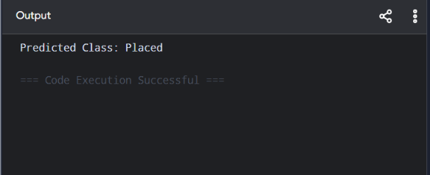

Dataset 3: Disease Diagnosis
Target Variable (Disease): Positive / Negative

Training Data
Temperature (C) | Heart Rate (bpm) | Oxygen Level (%) | Disease
39.2 | 112 | 93 | Positive
38.8 | 110 | 94 | Positive
37.0 | 78 | 99 | Negative
39.1 | 114 | 92 | Positive
36.8 | 76 | 98 | Negative
38.9 | 111 | 94 | Positive
37.2 | 80 | 99 | Negative
39.3 | 115 | 92 | Positive
36.7 | 74 | 98 | Negative
38.7 | 109 | 95 | Positive

New Sample for Classification
Temperature (C) | Heart Rate (bpm) | Oxygen Level (%)
38.9 | 110 | 94

PROGRAM

import numpy as np

X=np.array([[39.2,112,93],[38.8,110,94],[37,78,99],[39.1,114,92],
[36.8,76,98],[38.9,111,94],[37.2,80,99],[39.3,115,92],
[36.7,74,98],[38.7,109,95]],float)

y=np.array([1,1,0,1,0,1,0,1,0,1])

m=X.mean(0); s=X.std(0)
X=(X-m)/s

w=np.zeros(3); b=0

for _ in range(20):
for x,t in zip(X,y):
p=int(np.dot(x,w)+b>=0)
w+=(t-p)*x
b+=t-p

sample=(np.array([38.9,110,94])-m)/s
p=int(np.dot(sample,w)+b>=0)

print("Predicted Class:", "Positive" if p else "Negative")

OUTPUT

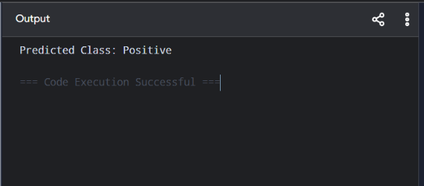

Dataset 4: Employee Promotion Classification
Target Variable (Promotion): Promoted / Not Promoted

Training Data
Experience (Years) | Performance Score | Training Hours | Promotion
10 | 95 | 50 | Promoted
9 | 92 | 48 | Promoted
8 | 90 | 45 | Promoted
4 | 72 | 28 | Not Promoted
3 | 68 | 24 | Not Promoted
11 | 96 | 52 | Promoted
5 | 75 | 30 | Not Promoted
8 | 89 | 44 | Promoted
2 | 60 | 18 | Not Promoted
7 | 87 | 40 | Promoted

New Sample for Classification
Experience (Years) | Performance Score | Training Hours
8 | 90 | 46

PROGRAM

import numpy as np

X=np.array([[10,95,50],[9,92,48],[8,90,45],[4,72,28],[3,68,24],
[11,96,52],[5,75,30],[8,89,44],[2,60,18],[7,87,40]],float)

y=np.array([1,1,1,0,0,1,0,1,0,1])

m=X.mean(0); s=X.std(0)
X=(X-m)/s

w=np.zeros(3); b=0

for _ in range(20):
for x,t in zip(X,y):
p=int(np.dot(x,w)+b>=0)
w+=(t-p)*x
b+=t-p

sample=(np.array([8,90,46])-m)/s
p=int(np.dot(sample,w)+b>=0)

print("Predicted Class:", "Promoted" if p else "Not Promoted")

OUTPUT

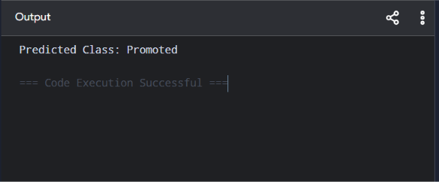

Dataset 5: Vehicle Classification
Target Variable (Vehicle Type): Bike / Car

Training Data
Engine Capacity (cc) | Weight (kg) | Mileage (km/L) | Vehicle Type
100 | 95 | 70 | Bike
125 | 110 | 65 | Bike
150 | 125 | 55 | Bike
800 | 850 | 22 | Car
1000 | 950 | 20 | Car
1200 | 1050 | 18 | Car
110 | 100 | 68 | Bike
900 | 900 | 21 | Car
140 | 120 | 58 | Bike
1300 | 1100 | 17 | Car

New Sample for Classification
Engine Capacity | Weight | Mileage
135 | 118 | 60

PROGRAM

import numpy as np

X=np.array([[100,95,70],[125,110,65],[150,125,55],[800,850,22],
[1000,950,20],[1200,1050,18],[110,100,68],[900,900,21],
[140,120,58],[1300,1100,17]],float)

y=np.array([0,0,0,1,1,1,0,1,0,1])

m=X.mean(0); s=X.std(0)
X=(X-m)/s

w=np.zeros(3); b=0

for _ in range(20):
for x,t in zip(X,y):
p=int(np.dot(x,w)+b>=0)
w+=(t-p)*x
b+=t-p

sample=(np.array([135,118,60])-m)/s
p=int(np.dot(sample,w)+b>=0)

print("Predicted Class:", "Car" if p else "Bike")

OUTPUT

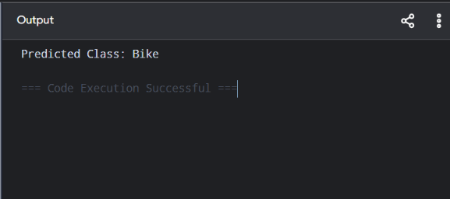

Tab 9
ITA0601
MACHINE LEARNING

EXP 19

Implementation of Naive Bayes classification for Bank Loan prediction

Procedure
1. Import the GaussianNB classifier.
2. Create the dataset and class labels.
3. Train the model using the training data.
4. Predict the loan approval status.
5. Display the predicted result.

Dataset 1: Personal Loan Approval Records
Target Variable: Loan Status (Approved / Rejected)

Annual Income (₹ Lakhs) | Credit Score | Loan Amount (₹ Lakhs) | Loan Status
12 | 820 | 5 | Approved
10 | 790 | 6 | Approved
9 | 760 | 7 | Approved
7 | 700 | 8 | Approved
6 | 680 | 9 | Rejected
5 | 650 | 10 | Rejected
4 | 620 | 12 | Rejected
8 | 730 | 8 | Approved
3 | 600 | 13 | Rejected
11 | 810 | 5 | Approved

New Test Sample
Annual Income (₹ Lakhs) | Credit Score | Loan Amount (₹ Lakhs)
9 | 770 | 6

PROGRAM

import numpy as np

X=np.array([[12,820,5],[10,790,6],[9,760,7],[7,700,8],
[6,680,9],[5,650,10],[4,620,12],[8,730,8],[3,600,13],[11,810,5]],float)
y=np.array([1,1,1,1,0,0,0,1,0,1])

def predict(x):
prob=[]
for c in [0,1]:
a=X[y==c]
mean=a.mean(0)
var=a.var(0)+1e-6
p=np.exp(-(x-mean)**2/(2*var))/np.sqrt(2*np.pi*var)
prob.append(p.prod()*len(a)/len(X))
return np.argmax(prob)

p=predict(np.array([9,770,6]))
print("Predicted Loan Status:", "Approved" if p else "Rejected")

OUTPUT

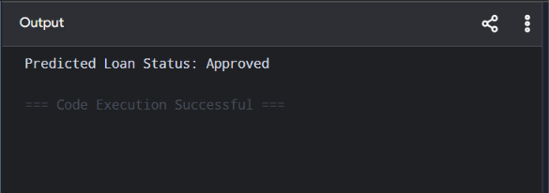

Dataset 2: Home Loan Approval Records
Target Variable: Loan Status (Approved / Rejected)

Monthly Salary (₹) | CIBIL Score | Existing EMI (₹) | Loan Status
90000 | 850 | 8000 | Approved
80000 | 820 | 9000 | Approved
70000 | 780 | 12000 | Approved
60000 | 740 | 15000 | Approved
50000 | 690 | 18000 | Rejected
45000 | 670 | 20000 | Rejected
40000 | 640 | 23000 | Rejected
75000 | 800 | 10000 | Approved
35000 | 620 | 25000 | Rejected
95000 | 870 | 7000 | Approved

New Test Sample
Monthly Salary (₹) | CIBIL Score | Existing EMI (₹)
72000 | 790 | 11000

PROGRAM

import numpy as np

X=np.array([[90000,850,8000],[80000,820,9000],[70000,780,12000],
[60000,740,15000],[50000,690,18000],[45000,670,20000],
[40000,640,23000],[75000,800,10000],[35000,620,25000],[95000,870,7000]],float)
y=np.array([1,1,1,1,0,0,0,1,0,1])

def predict(x):
prob=[]
for c in [0,1]:
a=X[y==c]
mean=a.mean(0)
var=a.var(0)+1e-6
p=np.exp(-(x-mean)**2/(2*var))/np.sqrt(2*np.pi*var)
prob.append(p.prod()*len(a)/len(X))
return np.argmax(prob)

p=predict(np.array([72000,790,11000]))
print("Predicted Loan Status:", "Approved" if p else "Rejected")

OUTPUT

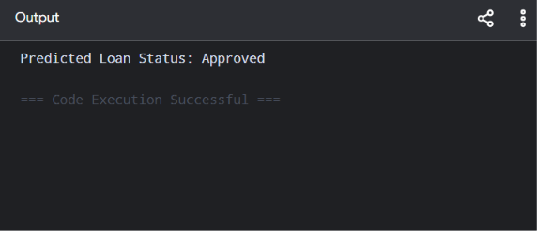

Dataset 3: Business Loan Approval Records
Target Variable: Loan Status (Approved / Rejected)

Business Income (₹ Lakhs) | Business Age (Years) | Existing Loans | Loan Status
20 | 10 | 1 | Approved
18 | 9 | 1 | Approved
15 | 8 | 2 | Approved
12 | 6 | 2 | Approved
10 | 5 | 3 | Rejected
8 | 4 | 3 | Rejected
6 | 3 | 4 | Rejected
16 | 8 | 2 | Approved
5 | 2 | 5 | Rejected
22 | 12 | 1 | Approved

New Test Sample
Business Income (₹ Lakhs) | Business Age (Years) | Existing Loans
17 | 8 | 2
PROGRAM

import numpy as np

X=np.array([[20,10,1],[18,9,1],[15,8,2],[12,6,2],[10,5,3],
[8,4,3],[6,3,4],[16,8,2],[5,2,5],[22,12,1]],float)
y=np.array([1,1,1,1,0,0,0,1,0,1])

def predict(x):
prob=[]
for c in [0,1]:
a=X[y==c]
mean=a.mean(0)
var=a.var(0)+1e-6
p=np.exp(-(x-mean)**2/(2*var))/np.sqrt(2*np.pi*var)
prob.append(p.prod()*len(a)/len(X))
return np.argmax(prob)

p=predict(np.array([17,8,2]))
print("Predicted Loan Status:", "Approved" if p else "Rejected")

OUTPUT

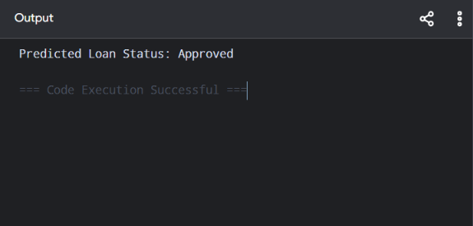

Dataset 4: Education Loan Approval Records
Target Variable: Loan Status (Approved / Rejected)

Family Income (₹ Lakhs) | Academic Score (%) | Loan Amount (₹ Lakhs) | Loan Status
15 | 92 | 6 | Approved
13 | 89 | 7 | Approved
11 | 85 | 8 | Approved
9 | 80 | 9 | Approved
7 | 72 | 10 | Rejected
6 | 68 | 11 | Rejected
5 | 65 | 12 | Rejected
12 | 87 | 7 | Approved
4 | 60 | 13 | Rejected
16 | 94 | 5 | Approved

New Test Sample
Family Income (₹ Lakhs) | Academic Score (%) | Loan Amount (₹ Lakhs)
12 | 88 | 7

PROGRAM

import numpy as np

X=np.array([[15,92,6],[13,89,7],[11,85,8],[9,80,9],[7,72,10],
[6,68,11],[5,65,12],[12,87,7],[4,60,13],[16,94,5]],float)
y=np.array([1,1,1,1,0,0,0,1,0,1])

def predict(x):
prob=[]
for c in [0,1]:
a=X[y==c]
mean=a.mean(0)
var=a.var(0)+1e-6
p=np.exp(-(x-mean)**2/(2*var))/np.sqrt(2*np.pi*var)
prob.append(p.prod()*len(a)/len(X))
return np.argmax(prob)

p=predict(np.array([12,88,7]))
print("Predicted Loan Status:", "Approved" if p else "Rejected")

OUTPUT

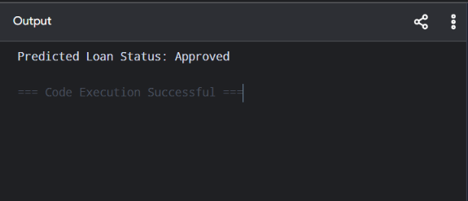

Dataset 5: Vehicle Loan Approval Records
Target Variable: Loan Status (Approved / Rejected)

Annual Income (₹ Lakhs) | Down Payment (₹ Lakhs) | Credit Score | Loan Status
14 | 3 | 830 | Approved
12 | 2.5 | 810 | Approved
10 | 2 | 780 | Approved
8 | 1.8 | 740 | Approved
7 | 1.5 | 690 | Rejected
6 | 1.2 | 660 | Rejected
5 | 1.0 | 630 | Rejected
11 | 2.2 | 790 | Approved
4 | 0.8 | 600 | Rejected
15 | 3.5 | 850 | Approved

New Test Sample
Annual Income (₹ Lakhs) | Down Payment (₹ Lakhs) | Credit Score
11 | 2.4 | 800

PROGRAM

import numpy as np

X=np.array([[14,3,830],[12,2.5,810],[10,2,780],[8,1.8,740],
[7,1.5,690],[6,1.2,660],[5,1,630],[11,2.2,790],
[4,.8,600],[15,3.5,850]],float)
y=np.array([1,1,1,1,0,0,0,1,0,1])

def predict(x):
prob=[]
for c in [0,1]:
a=X[y==c]
mean=a.mean(0)
var=a.var(0)+1e-6
p=np.exp(-(x-mean)**2/(2*var))/np.sqrt(2*np.pi*var)
prob.append(p.prod()*len(a)/len(X))
return np.argmax(prob)

p=predict(np.array([11,2.4,800]))
print("Predicted Loan Status:", "Approved" if p else "Rejected")

OUTPUT

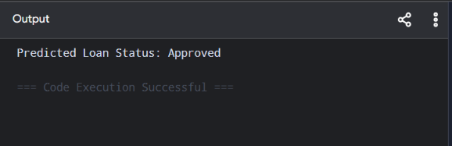

Tab 10
ITA0601
MACHINE LEARNING

EXP 20

Implement Future Sales Prediction using a suitable machine learning algorithm

Procedure
1. Import the Linear Regression model.
2. Create the dataset and target values.
3. Train the model using the training data.
4. Predict future sales for a new input.
5. Display the predicted result

Dataset 1: Monthly Product Sales
Advertising Budget (₹ Thousands) | Number of Salespersons | Monthly Sales (Units) [Target Variable]
20 | 2 | 100
25 | 2 | 120
30 | 3 | 150
35 | 3 | 170
40 | 4 | 200
45 | 4 | 220
50 | 5 | 250
55 | 5 | 270
60 | 6 | 300
65 | 6 | 320

New Sample Data for Prediction:
Advertising Budget (₹ Thousands) | Number of Salespersons
48 | 5

PROGRAM

import numpy as np

X=np.array([[20,2],[25,2],[30,3],[35,3],[40,4],
[45,4],[50,5],[55,5],[60,6],[65,6]],float)
y=np.array([250,290,340,390,450,510,580,640,710,780],float)

X1=np.c_[np.ones(len(X)),X]
b=np.linalg.pinv(X1.T@X1)@X1.T@y

new=np.array([1,48,5])
print("Predicted Future Sales:",round(new@b,2))

OUTPUT

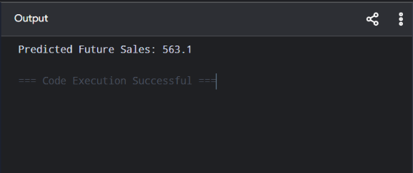

Dataset 2: Retail Store Sales
Store Area (sq.ft) | Daily Customers | Monthly Sales (₹ Lakhs) [Target Variable]
1000 | 120 | 8
1200 | 150 | 10
1400 | 180 | 12
1600 | 220 | 15
1800 | 260 | 18
2000 | 300 | 22
2200 | 340 | 26
2400 | 380 | 31
2600 | 420 | 36
2800 | 460 | 42

New Sample Data for Prediction:
Store Area (sq.ft) | Daily Customers
2100 | 320

PROGRAM

import numpy as np

X=np.array([[1000,120],[1200,150],[1400,180],[1600,220],[1800,260],
[2000,300],[2200,340],[2400,380],[2600,420],[2800,460]],float)
y=np.array([8,10,12,15,18,22,26,31,36,42],float)

X1=np.c_[np.ones(len(X)),X]
b=np.linalg.pinv(X1.T@X1)@X1.T@y

new=np.array([1,2100,320])
print("Predicted Future Sales:",round(new@b,2),"Lakhs")

OUTPUT

